**Kubernetes**

**What is Kubernetes (k8s)?**

**Kubernetes** is an open-source Container Management tool that automates container deployment, container scaling, descaling, and container load balancing (also called a container orchestration tool).

It is an open-source container orchestration platform that automates the deployment, management, and scaling of container-based applications

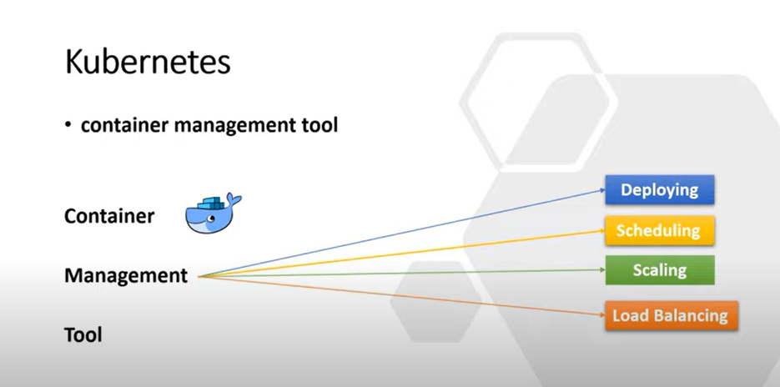

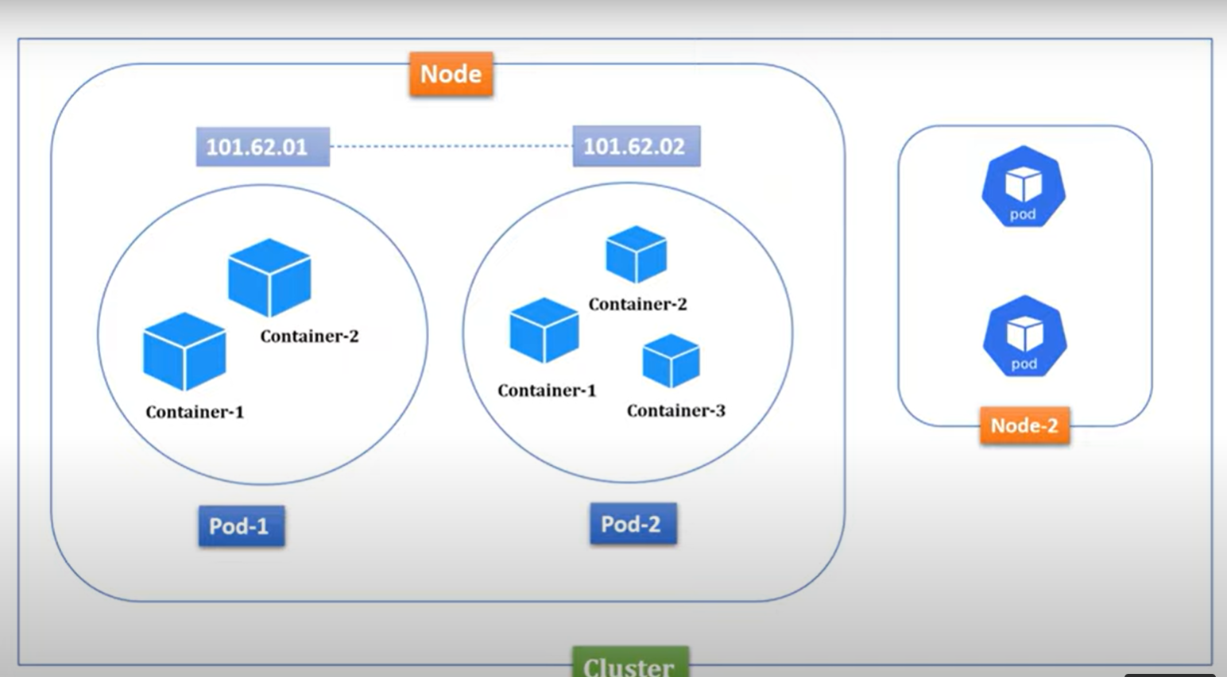

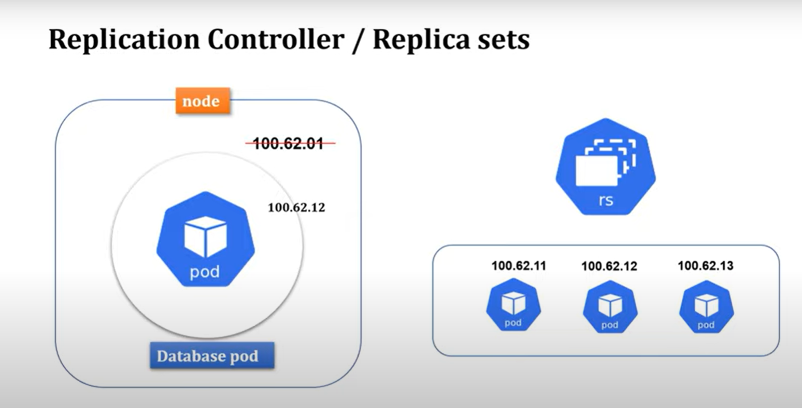

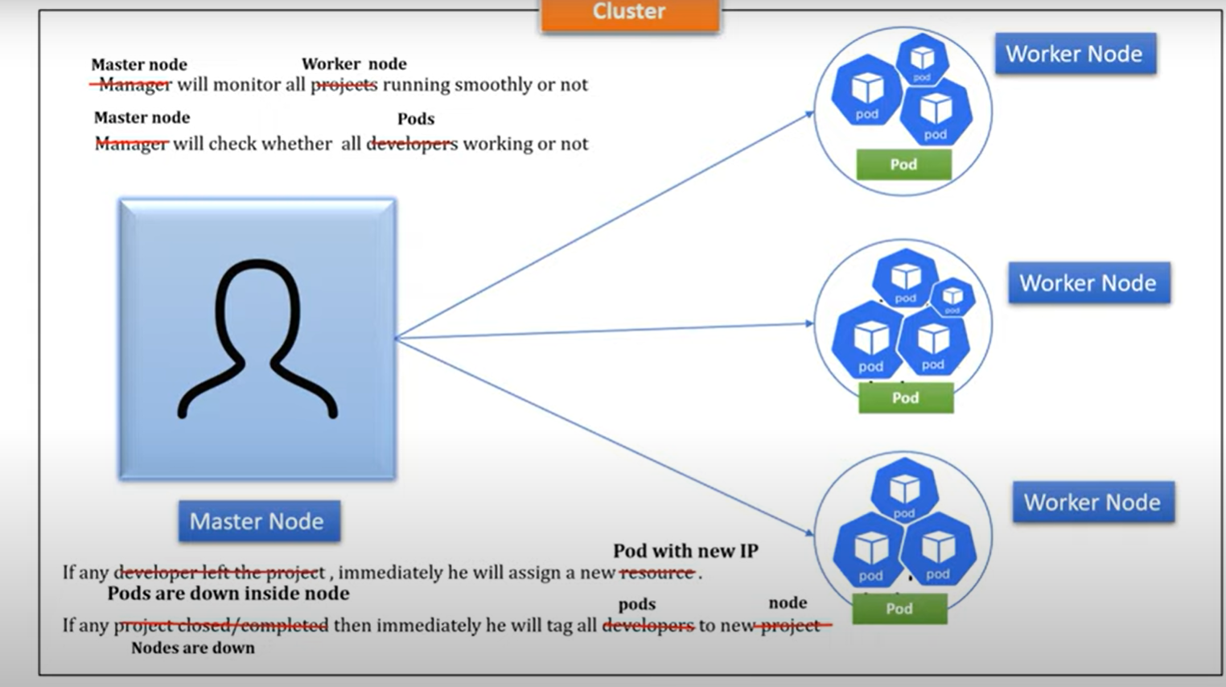

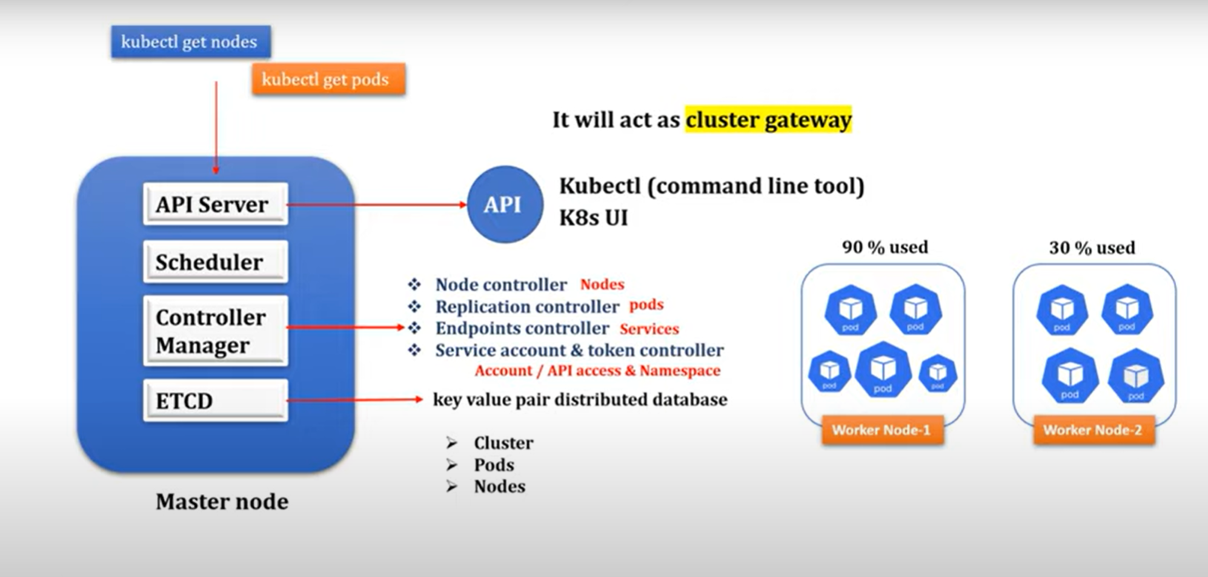

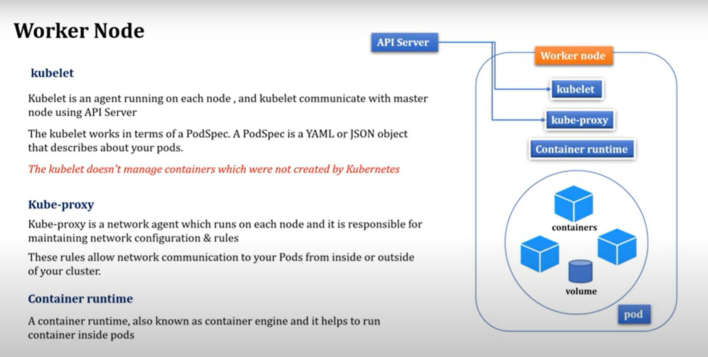

Kubernetes is an open-source platform that manages Docker containers in the form of a cluster.

Along with the automated deployment and scaling of containers, it provides healing by automatically restarting failed containers and rescheduling them when their hosts die.

## ****Benefits of Using Kubernetes****

### 1. Automated deployment and management

### 2. Scalability

### 3. High availability

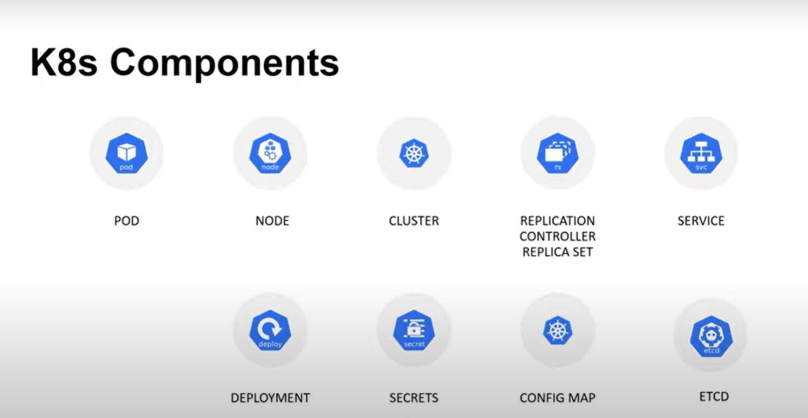

### **Key Objects of Kubernetes**

**Pod**

It is the smallest and simplest basic unit of the Kubernetes application. This object indicates the processes which are running in the cluster.

It is the smallest and simplest basic unit of the Kubernetes application. This object indicates the processes which are running in the cluster.

**Service**

A **service** in a Kubernetes is a logical set of pods, which works together. With the help of services, users can easily manage load balancing configurations.

**ReplicaSet**

A **ReplicaSet** in the Kubernetes is used to identify the particular number of pod replicas are running at a given time. It replaces the replication controller because it is more powerful and allows a user to use the "set-based" label selector.

1. **Pod:** It is a deployment unit in Kubernetes with a single Internet protocol address.
2. **Horizontal Scaling:** It is an important feature in the Kubernetes. This feature uses a **HorizontalPodAutoscalar** to automatically increase or decrease the number of pods in a deployment, replication controller, replica set, or stateful set on the basis of observed CPU utilization.
3. **Automatic Bin Packing:** Kubernetes helps the user to declare the maximum and minimum resources of computers for their containers.
4. **Service Discovery and load balancing:** Kubernetes assigns the IP addresses and a Name of DNS for a set of containers, and also balances the load across them.
5. **Automated rollouts and rollbacks:** Using the rollouts, Kubernetes distributes the changes and updates to an application or its configuration. If any problem occurs in the system, then this technique rollbacks those changes for you immediately.
   1. **.Self-Healing:** This feature plays an important role in the concept of Kubernetes. Those containers which are failed during the execution process, Kubernetes restarts them automatically. And, those containers which do not reply to the user-defined health check, it stops them from working automatically.

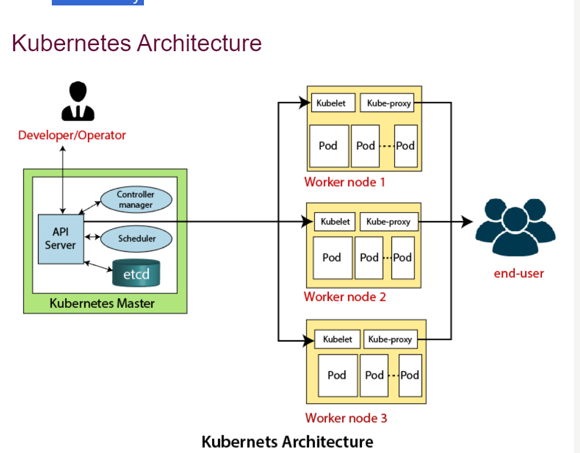

The architecture of Kubernetes actually follows the client-server architecture. It consists of the following two main components:

1. Master Node (Control Plane)
2. Slave/worker node

### **Master Node or Kubernetes Control Plane**

The master node in a Kubernetes architecture is used to manage the states of a cluster. It is actually an entry point for all types of administrative tasks. In the Kubernetes cluster, more than one master node is present for checking the fault tolerance.

Following are the four different components which exist in the Master node or Kubernetes Control plane:

1. API Server
2. Scheduler
3. Controller Manager
4. ETCD

**API Server**

The Kubernetes API server receives the REST commands which are sent by the user. After receiving, it validates the REST requests, process, and then executes them. After the execution of REST commands, the resulting state of a cluster is saved in '**etcd**' as a distributed key-value store.

**Scheduler**

The scheduler in a master node schedules the tasks to the worker nodes. And, for every worker node, it is used to store the resource usage information.  
In other words, it is a process that is responsible for assigning pods to the available worker nodes.

**Controller Manager**

The Controller manager is also known as a controller. It is a daemon that executes in the non-terminating control loops. The controllers in a master node perform a task and manage the state of the cluster. In the Kubernetes, the controller manager executes the various types of controllers for handling the nodes, endpoints, etc.

**ETCD**

It is an open-source, simple, distributed key-value storage which is used to store the cluster data. It is a part of a master node which is written in a GO programming language.

Now, we have learned about the functioning and components of a master node; let's see what is the function of a slave/worker node and what are its components.

### **Worker/Slave node**

The Worker node in a Kubernetes is also known as minions. A worker node is a physical machine that executes the applications using pods. It contains all the essential services which allow a user to assign the resources to the scheduled containers.

Following are the different components which are presents in the Worker or slave node:

**Kubelet**

This component is an agent service that executes on each worker node in a cluster. It ensures that the pods and their containers are running smoothly. Every **kubelet** in each worker node communicates with the master node. It also starts, stops, and maintains the containers which are organized into pods directly by the master node.

**Kube-proxy**

It is a proxy service of Kubernetes, which is executed simply on each worker node in the cluster. The main aim of this component is request forwarding. Each node interacts with the Kubernetes services through **Kube-proxy**.

**Pods**

A **pod** is a combination of one or more containers which logically execute together on nodes. One worker node can easily execute multiple pods.

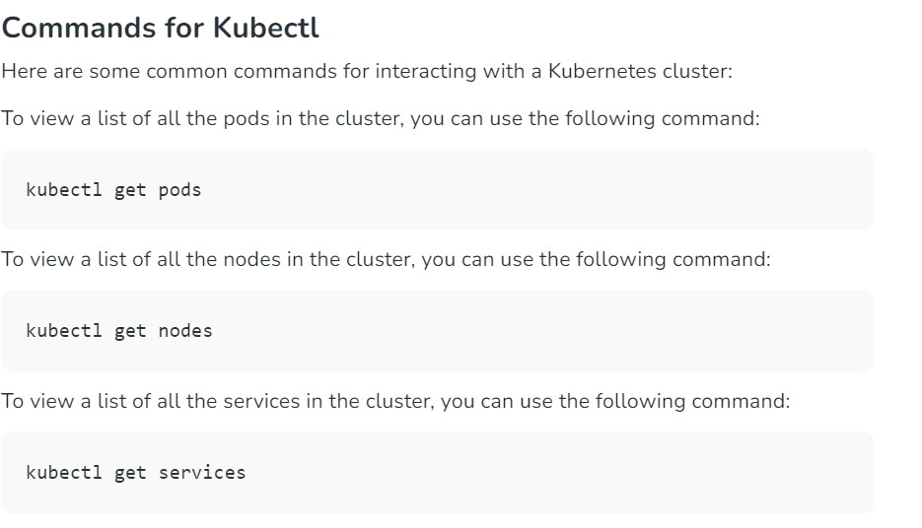

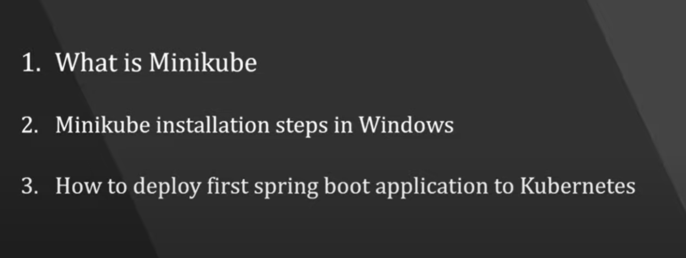 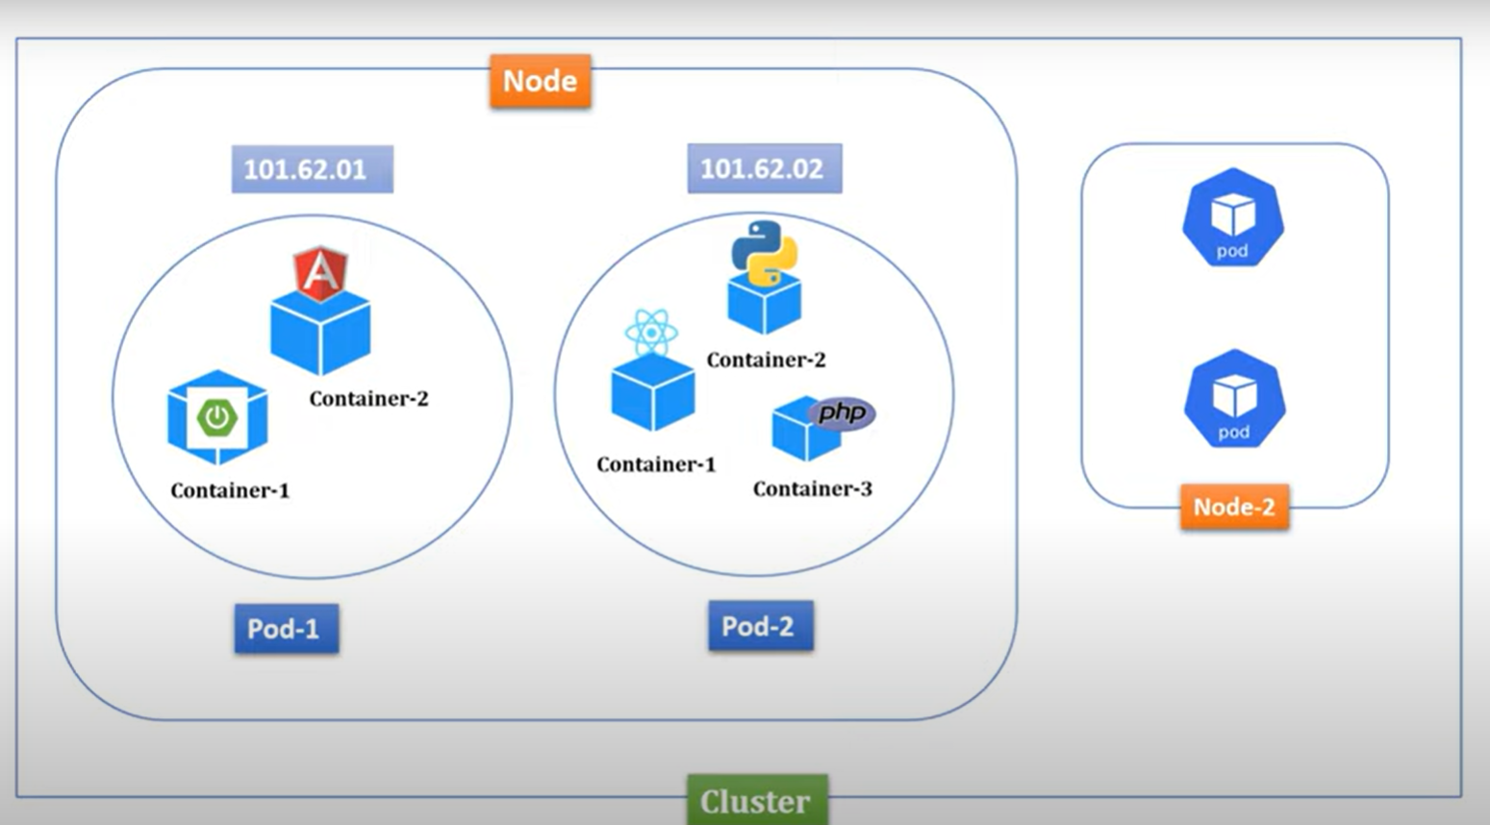 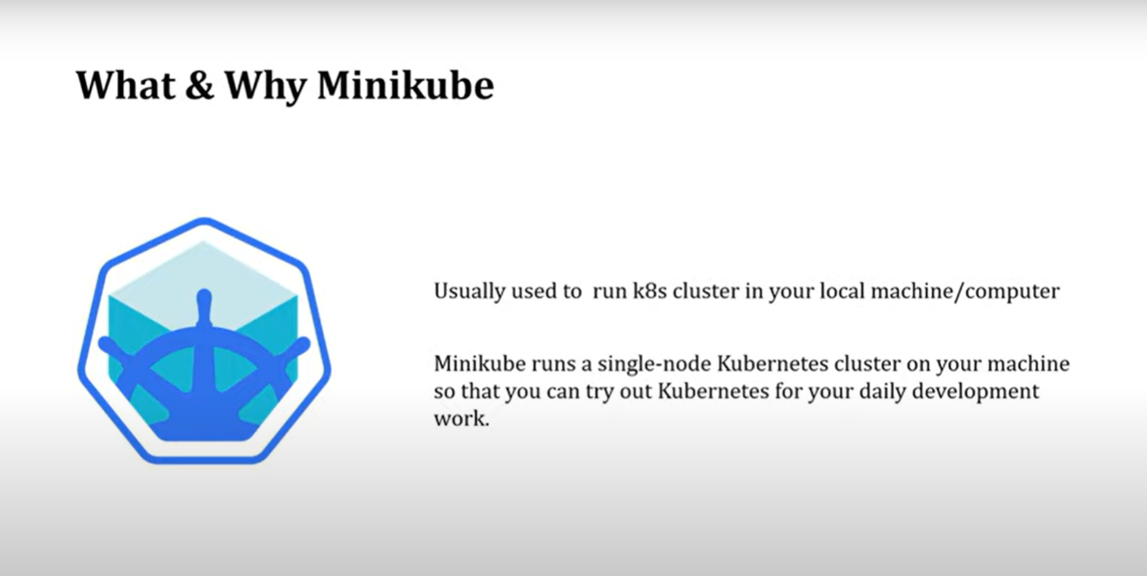

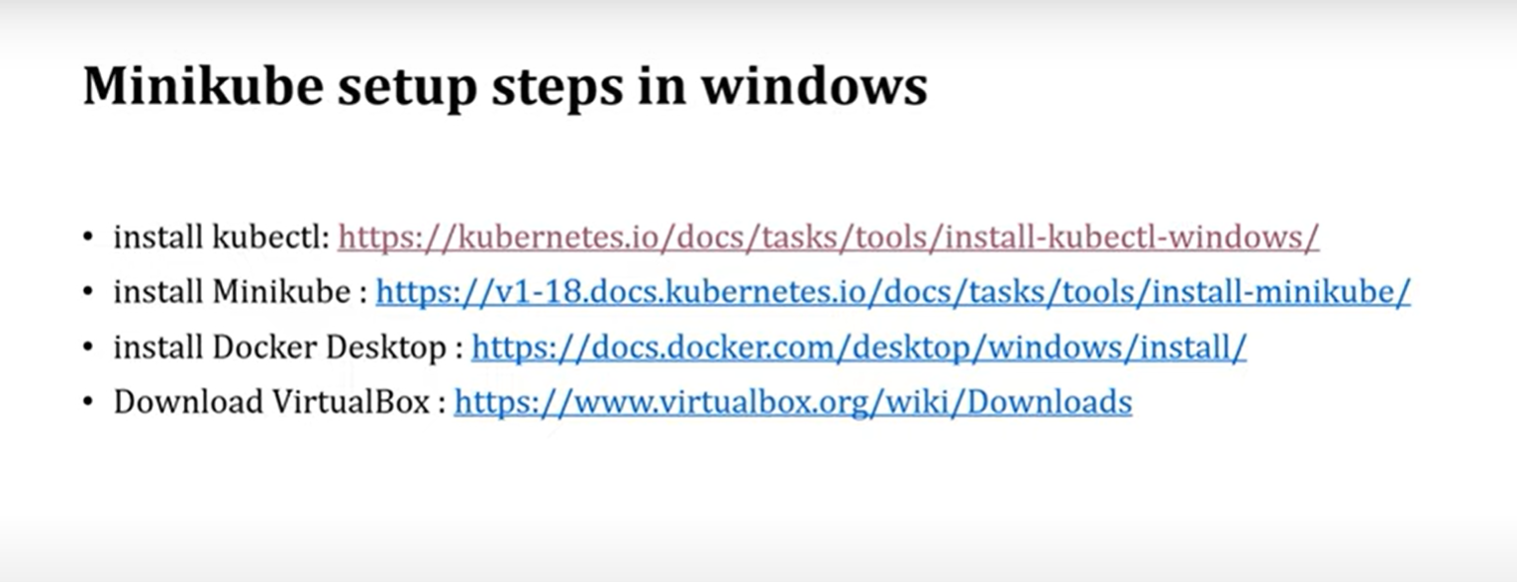

Download and install

And add the env variable of both application

And Open the cmd and check the version :



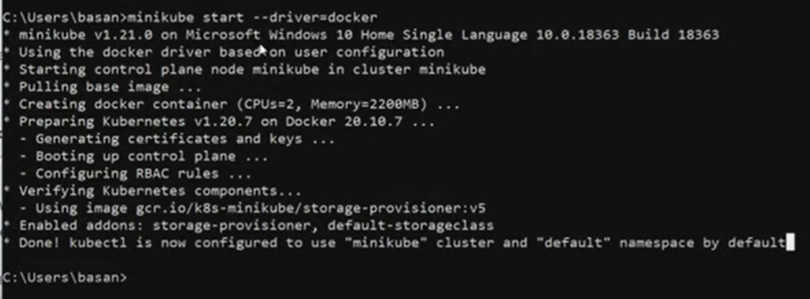

Check the status of mini cube using the below cmd

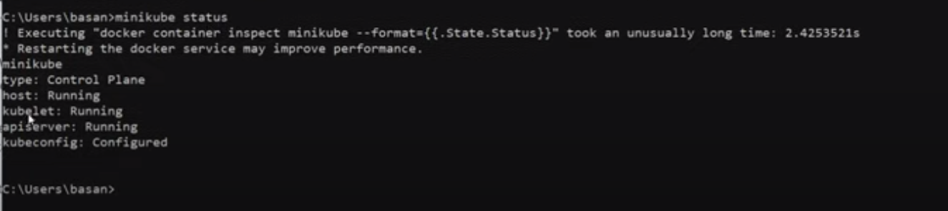

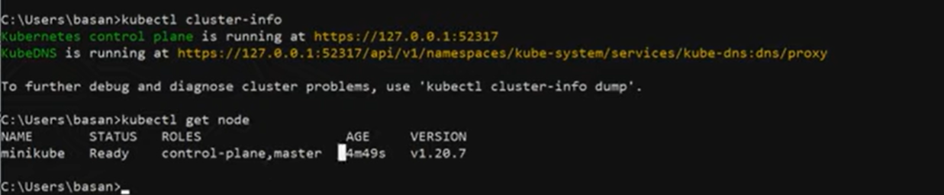

Practical :

Create a Simple Spring boot application

1 ) Create a controller file

2) in the controller and create a API

Getmapping(“/enrty”)

Void entry(){

---- return the string   
}

3) Create a docker file

Add the previous docker file which we learnt before

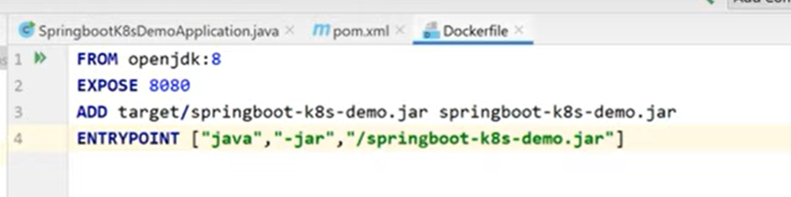 4) docker build and create a image

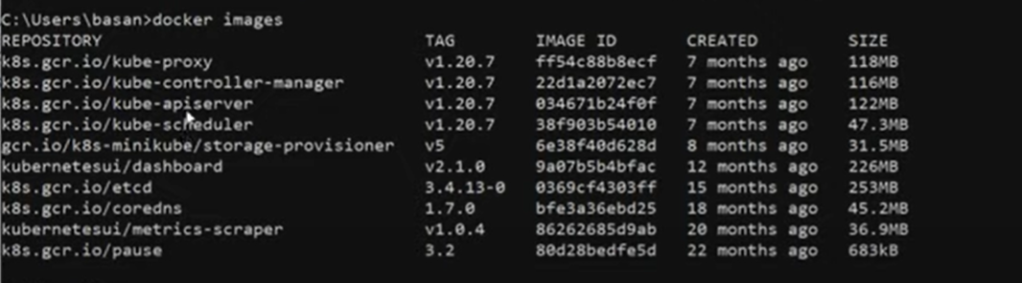 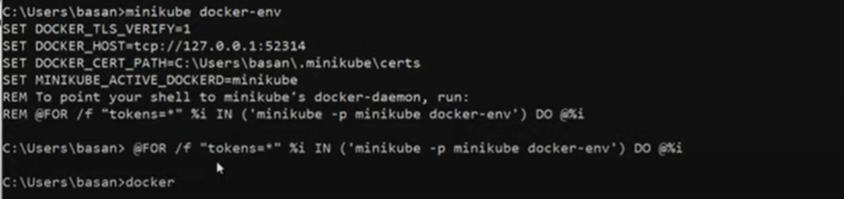

5 ) go to the project location and build



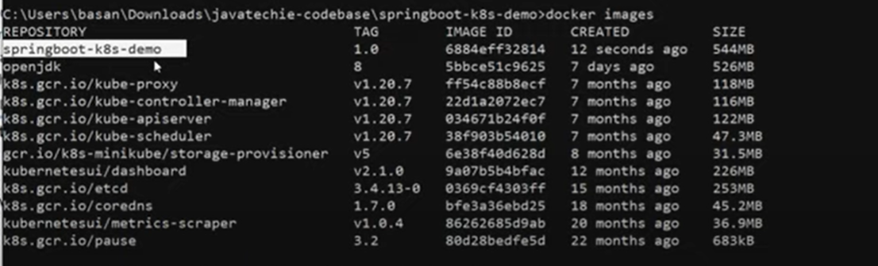

Next run :

Kubectl create deployment springboot-k8s --image=springboot-k8s-demo:1.0 –port=8080

To check

Kubectl get deployment

To describe the app

Kubectl describe deployment spring-boot-k8s

To get the pods

Kubectl get pods



We will get the pod names and copy the name of the pods then run by usig the below cmd

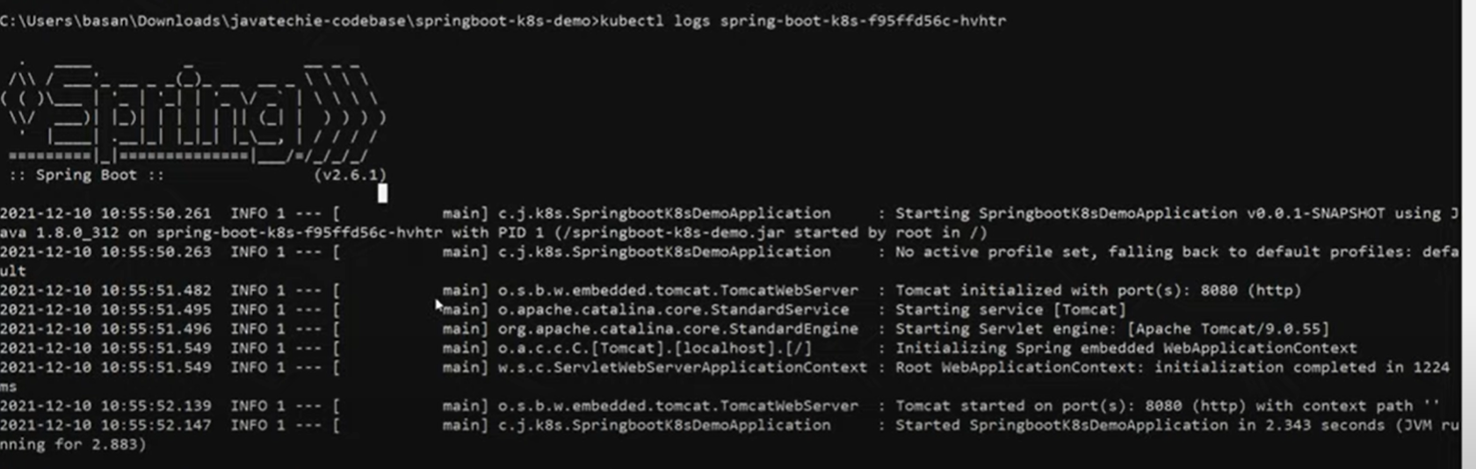

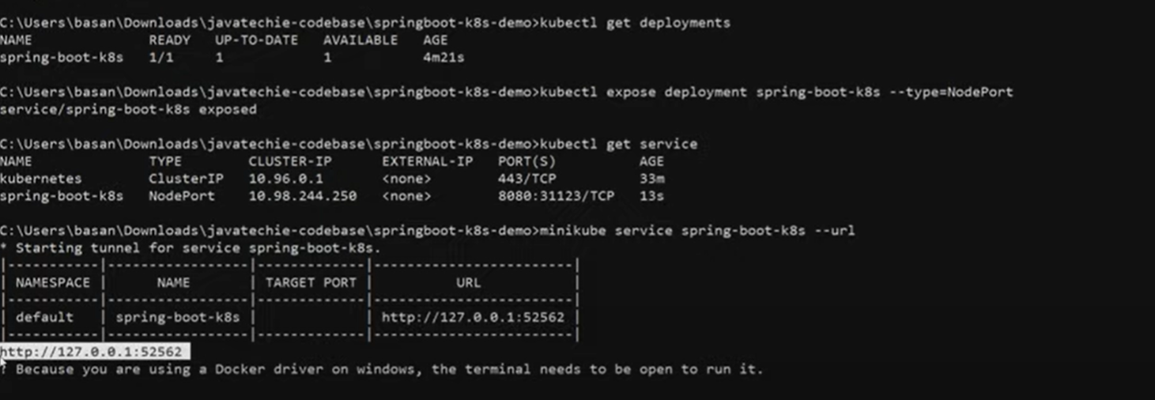

To open the minicube desktop use the below cmd

>Minicube dashboard

Open the http in browser with your Api

U will be able to execute the application

